Exp no:11 Determination and plotting of Magnetic Flux density in Ferromagnetic Materials with different (i) length, (ii) width and (iii) magnetic field intensity.
Aim:
To write program for Magnetic flux density in ferromagnetic materials using SCILAB.
Software required:
•SCILAB version 6.0.1
Theory:
The magnetic flux density (B) in ferromagnetic materials is a measure of the magnetic field’s strength within the material, which takes into account both the external magnetic field (H) and the material's inherent magnetic properties (i.e., its magnetization). The relationship between these quantities in a ferromagnetic material is more complex than in non-magnetic or paramagnetic materials because ferromagnetic materials exhibit hysteresis, saturation, and non-linear behavior due to their spontaneous magnetization.
Code:
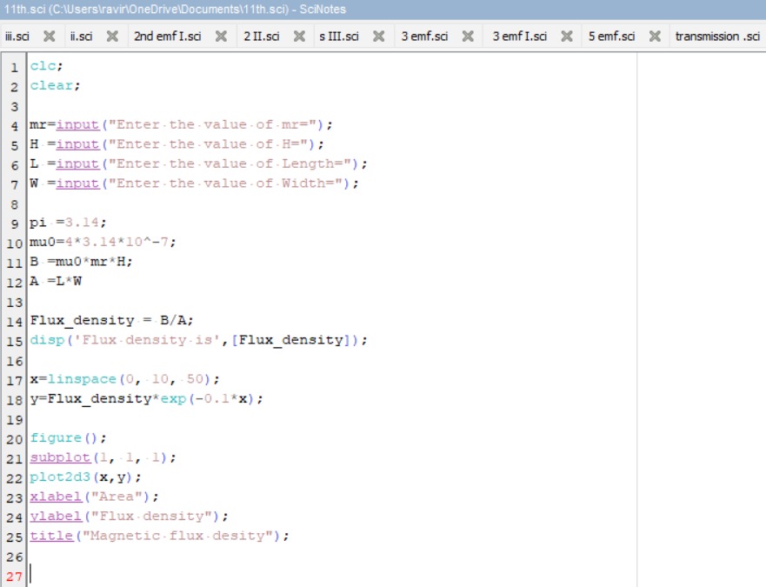
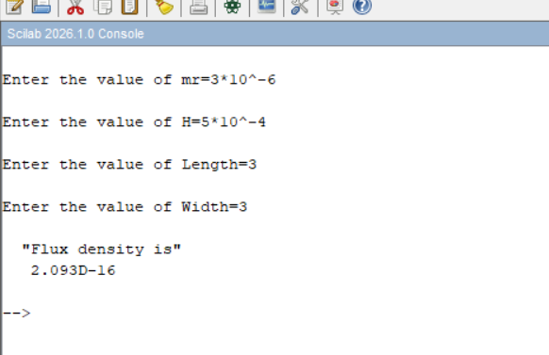
Output:
Graph:
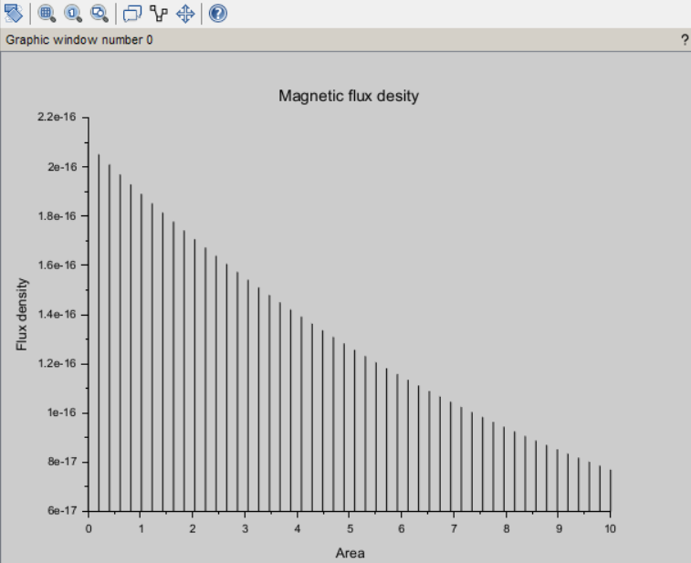
Result :
Thus the program was verified for program for Magnetic flux density in ferromagnetic materials using SCILAB was successfully.
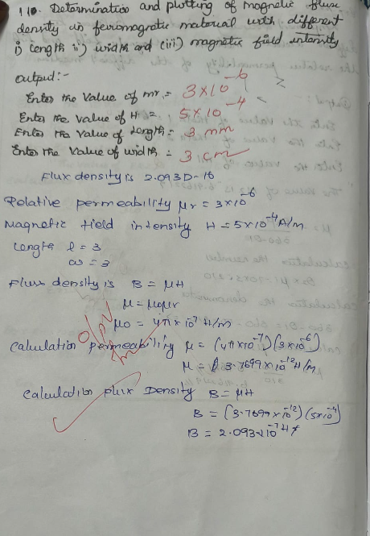
Case 1: Examine the effect of length of a ferromagnetic material on the magnetic flux density (B).
Analytical :
Calculate the magnetic flux density for the following conditions
- The material is ferromagnetic with relative permeability (μr​) of 500.
- The magnetic field intensity (H) is held constant at 100 A/m.
- The length of the material varies from 0.1 m to 2 m.

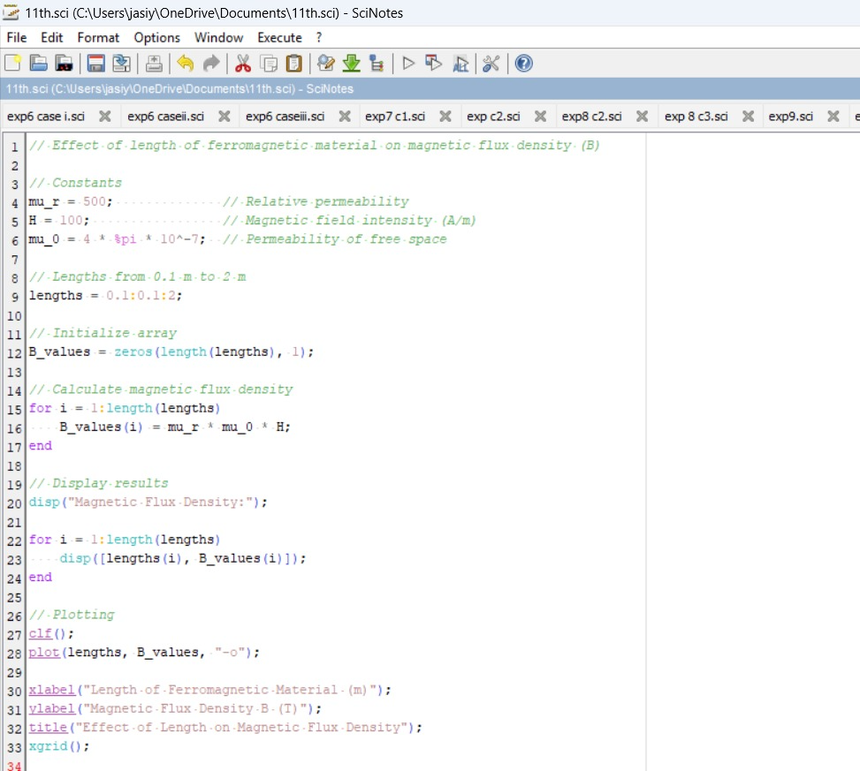
Code:

Output:
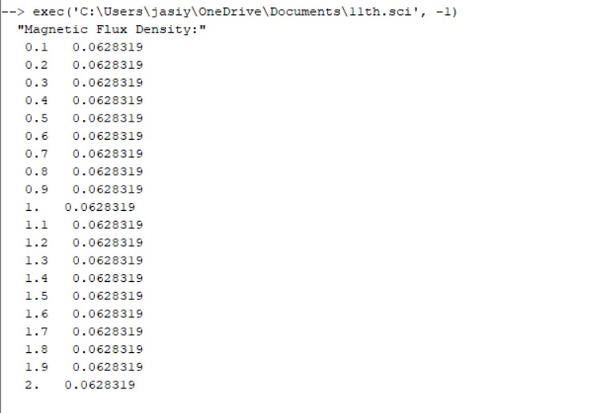

Graph:
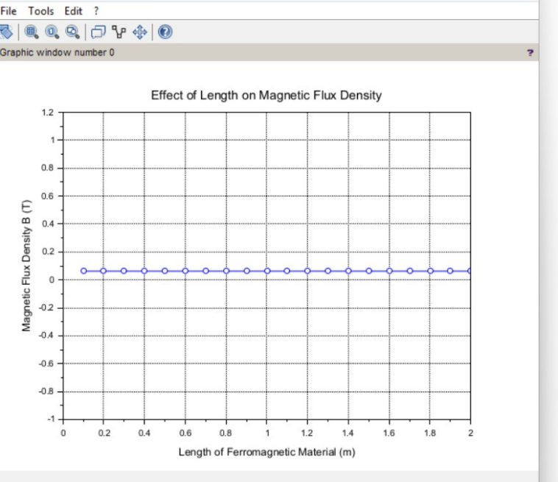
Case 2: To investigate how the magnetic flux density (B) in a ferromagnetic material changes with different widths at a constant length and magnetic field intensity.
Conditions:
- Material: Soft iron (same as in Case Study 1)
- Length (L): Constant at 10 cm
- Magnetic Field Intensity (H): Constant at 1000 A/m
- Width (W): Varies from 2 cm to 10 cm (i.e., 2 cm, 4 cm, 6 cm, 8 cm, 10 cm)
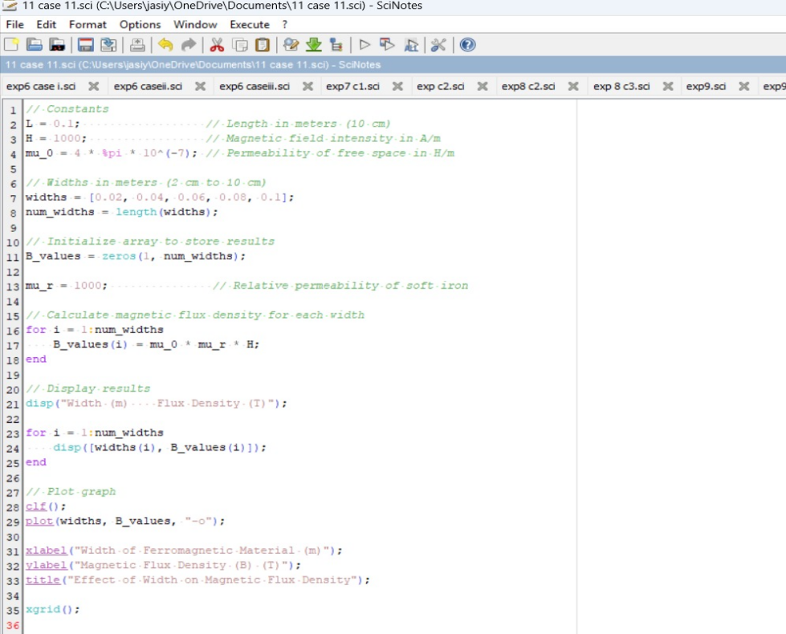
Output:
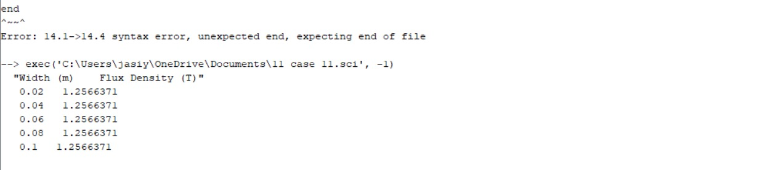
Case 3: To examine how the magnetic flux density (B) in a ferromagnetic material changes with different values of magnetic field intensity at constant length and width.
Conditions:
- Material: Soft iron (same as in the previous studies)
- Length (L): Constant at 10 cm
- Width (W): Constant at 5 cm
- Magnetic Field Intensity (H): Varies from 200 A/m to 2000 A/m (i.e., 200 A/m, 500 A/m, 1000 A/m, 1500 A/m, 2000 A/m)
Code:
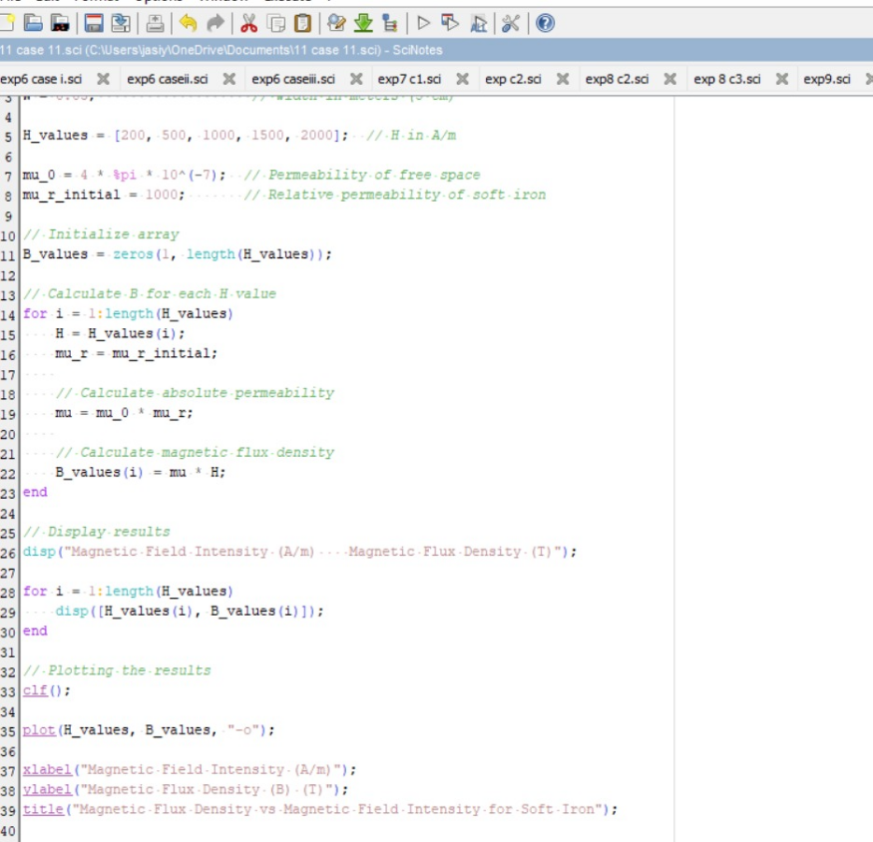

Output:
